INDEX :

|  |
| --- |
| **Project Definition** |
| **Design Thinking** |
| • Project Objectives |
| • IoT Sensor Designs |
| • Real-Time Transit |
| • Integration Approach |

**ABSTRACTION**:

Public transportation optimization is the process of improving the efficiency and effectiveness of public transportation systems. This can be done by a variety of means, such as:

* Improving vehicle scheduling: Optimizing vehicle schedules can help to reduce waiting times and improve service frequency.
* Designing efficient routes: Designing efficient routes can help to reduce travel times and fuel consumption.
* Coordinating different modes of transportation: Coordinating different modes of transportation, such as buses and trains, can make it easier for passengers to get around.
* Improving infrastructure: Investing in public transportation infrastructure, such as new bus lanes and train stations, can improve the overall quality of service.

Public transportation optimization is a complex problem, as it involves a variety of factors, such as passenger demand, vehicle availability, and budget constraints. However, a number of optimization techniques can be used to find solutions that improve the overall efficiency and effectiveness of public transportation systems.

One common approach to public transportation optimization is to use mathematical models. These models can be used to represent the complex relationships between the different factors involved in public transportation systems. Once a model has been developed, it can be used to evaluate different scenarios and identify the one that produces the best outcome.

**1.Project Objectives**:

Real-time transit information systems provide passengers with instant access to route details and vehicle locations, while arrival time prediction algorithms enhance journey planning. Ridership monitoring helps optimize routes and schedules by analyzing passenger demographics and travel patterns. The overarching aim is to elevate public transportation, including vehicle upgrades and sustainability measures, creating a more accessible, efficient, and eco-friendly transit system for all.

**2. IoT Sensor Design:**

The deployment of IoT sensors in public transportation vehicles involves a strategic plan. Begin with a needs assessment to define objectives, select suitable sensors like GPS and passenger counters, and ensure robust data connectivity. Install sensors securely, establish a central data management platform, and integrate sensor data for route optimization. Implement real-time monitoring for vehicle tracking and passenger communication for enhanced services.

Prioritize data security and maintenance, analyzing collected data for informed decisions and compliance with privacy regulations. Finally, plan for scalability to accommodate future expansion of the sensor network as the transportation system evolves.

**3.Real-Time Transit Information Platform**:

The web-based platform aims to provide passengers with a user-friendly interface for accessing real-time transit information. It integrates data from IoT sensors on public transportation vehicles, including GPS and passenger counters. Key features include interactive route maps, current schedules, estimated arrival times, trip planning tools, and personalized alerts.

The platform prioritizes accessibility for all users, adheres to stringent data security and privacy measures, and may incorporate multi-modal transportation information for seamless journeys. Overall, it aims to enhance the passenger experience and facilitate efficient and informed transit use. 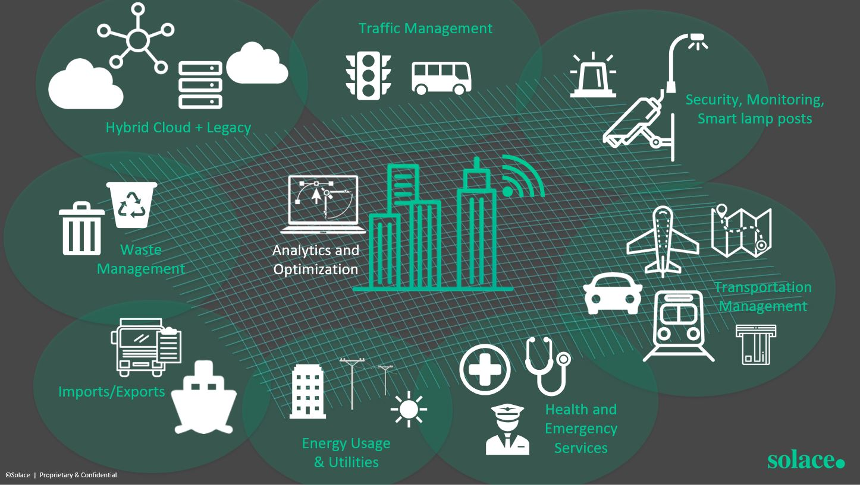

4.Integration Approach:

IoT sensors in public transportation vehicles collect data such as GPS location and passenger counts, which is processed and formatted into structured messages. These sensors utilize wireless communication methods, including cellular networks, Wi-Fi, or specialized protocols like LoRaWAN or satellite, to transmit data to a cloud-based platform.

This platform receives, validates, and stores the data in databases, making it accessible through APIs. The real-time transit information platform then retrieves and displays this data on a user-friendly web interface for passengers, providing up-to-the-minute information about public transportation services.

Another approach to public transportation optimization is to use simulation. Simulation models can be used to create a virtual representation of a public transportation system. This model can then be used to test different optimization strategies and see how they affect the system's performance.

Public transportation optimization is an important area of research, as it can help to improve the quality of life for millions of people who rely on public transportation to get around. By developing and implementing effective optimization strategies, we can make public transportation more efficient, effective, and accessible for everyone.

Here are some examples of how public transportation optimization can be used to improve the performance of public transportation systems:

* Reduce travel times: Public transportation optimization can be used to reduce travel times by improving vehicle scheduling, designing efficient routes, and coordinating different modes of transportation.
* Improve reliability: Public transportation optimization can be used to improve reliability by reducing waiting times and increasing service frequency.
* Increase ridership: Public transportation optimization can be used to increase ridership by making public transportation more convenient, affordable, and accessible.
* Reduce costs: Public transportation optimization can be used to reduce costs by improving fuel efficiency and reducing the number of vehicles required to operate the system.

Public transportation optimization is a complex and challenging task, but it is essential for improving the performance of public transportation systems. By developing and implementing effective optimization strategies, we can make public transportation more efficient, effective, and accessible for everyone.

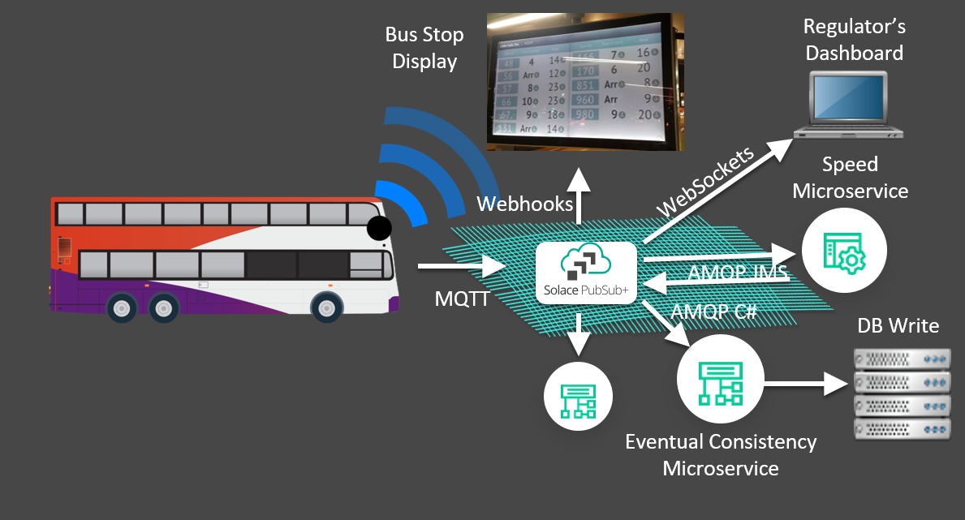

CONCLUSION:

Given the increasing need for crowd management systems

in today’s public transport and the paucity of IoT imple-

mentation in the same, this project has demonstrated a

robust, cheap and scalable system to mange crowds in

public transport. The software simulation was carried out

to check feasibility of such a system to work in a real time

environment. The project design was built and tested for

various loads and seating profiles to better estimate the

threshold. The prototype was built and tested in real time

seating environments. The final results show promise for

implementation in the real world. Further work can be

done to account for standing passengers, implementing

addressing schemes to increase scalability and introduce

web development to improve the webpage interface.